Regulated DC Power Supply to run an LED

Contents

[Problem Statement: 2](#_Toc515359143)

[Solution: 2](#_Toc515359144)

[Theory behind the circuit 3](#_Toc515359145)

[Steps in building the circuit 3](#_Toc515359146)

[Step 1: Circuit Designing 3](#_Toc515359147)

[Step2. Circuit Drawing and Simulation 5](#_Toc515359148)

# **Problem Statement**:

Design a regulated DC power supply of 5V which can be used to run a LED, using AC voltage as the input.

# **Solution**:

You all must be aware of regulated DC power supply. If not, let me give a brief idea. Actually, most of the circuits or [electronic devices](http://www.edgefxkits.com/tv-remote-operated-domestic-appliances-control) require a DC voltage for their operation. We can use simple batteries to provide the voltage, but the major problem with batteries is their limited life time. For this reason, the only way we have, is to convert the AC voltage supply at our homes to the required DC voltage.

All we need is to convert this AC voltage into DC voltage. But it is not as simple as it seems. So, let us have a brief theoretical idea about how AC voltage is converted into regulated DC voltage.

[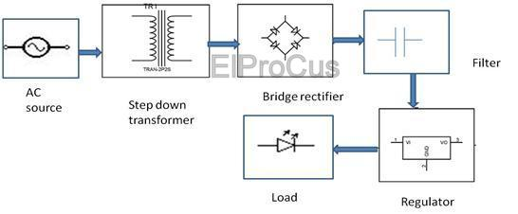](https://www.elprocus.com/wp-content/uploads/2013/11/Bridge-Rectifier.jpg)Block Diagram by [ElProCus](https://www.elprocus.com/" \t "_blank)

# Theory behind the circuit

1. AC voltage from the supply at 230V is first stepped down to low voltage AC using a step down transformer. A transformer is a device with two windings –primary and secondary, wherein voltage applied across the primary winding , appears across the secondary winding by the virtue of inductive coupling. Since secondary coil has lesser number of turns, the voltage across the secondary is less than the voltage across the primary for a step down transformer.
2. This low AC voltage is converted to pulsating DC voltage using bridge rectifier. A bridge rectifier is an arrangement of 4 diodes placed in bridged form, such that anode of one diode and cathode of another diode are connected together to positive terminal of the voltage source and in the same way the anode and cathode of another two diodes are connected to the negative terminal of the voltage source. Also the cathodes of two diodes are connected together to the positive polarity of the voltage and the anode of two diodes is connected together to the negative polarity of the output voltage. For each half cycle, the opposite pair of diodes conducts and pulsating DC voltage is obtained across the bridge rectifiers.
3. The pulsating DC voltage thus obtained contains ripples in form of AC voltage. To remove these ripples a filter is needed which filters out the ripples from the DC voltage. A capacitor is placed in parallel to the output such that the capacitor (because of its impedance) allows high frequency AC signals to pass through get bypassed to ground and low frequency or DC signal is blocked. Thus the capacitor acts as a low pass filter.
4. The output produced from a capacitor filter is the unregulated DC voltage. To produce a regulated DC voltage a regulator is used which develops a constant DC voltage.

So let us now get into designing a simple AC-DC regulated power supply circuit to drive a LED.

# Steps in building the circuit

## Step 1: Circuit Designing

To design a circuit, we need to have idea about the values of each component required in the circuit. Let us now see how we are actually designing a regulated DC power supply circuit.

**1. Decide the regulator to be used and its input voltage.**

Here our requirement is to have a constant voltage of 5V at 20mA with positive polarity of the output voltage. For this reason we need a regulator which would provide a 5V output. An ideal and efficient choice would be the regulator IC LM7805. Our next requirement is to calculate the input voltage requirement for the regulator. For a regulator, the minimum input voltage should be the output voltage added by a value of three. In that case, here to have a voltage of 5V, we need a minimum input voltage of 8V. Let us settle down for an input of 12V.

[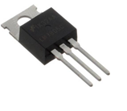](https://www.elprocus.com/wp-content/uploads/2013/11/7805-regulator.png)7805 regulator by [Flickr](http://farm3.staticflickr.com/2680/4149945173_9ca4c43c13_z.jpg?zz=1)

**2. Decide the transformer to be used**

Now the unregulated voltage produced is a voltage of 12V. This is the RMS value of the secondary voltage required for a transformer. Since the primary voltage is 230V RMS, on calculating the turns ratio, we get a value of 19. Hence we have to get a transformer with 230V/12V , i.e. a 12V, 20mA transformer.

[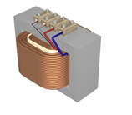](https://www.elprocus.com/wp-content/uploads/2013/11/Step-down-transformer.png)Step down transformer by [Wiki](http://upload.wikimedia.org/wikipedia/commons/7/7a/Transformer-hightolow_smaller.jpg)

**3. Decide the value of the filter capacitor**

The value of the filter capacitor depends on the amount of current drawn by the load, the quiescent current (ideal current) of the regulator, the amount of allowable ripple in the DC output and the time period.

For the peak voltage across the transformer primary to be 17V(12\*sqrt2) and the total drop across the diodes to be (2\*0.7V) 1.4V, the peak voltage across the capacitor is about 15V approx. We can calculate the amount of allowable ripple by the formula below:

∆V = VpeakCap- Vmin

As calculated, Vpeakcap = 15V and Vmin is the minimum voltage input for the regulator. Thus ∆V is (15-7)= 8V.

Now, Capacitance, C =( I\*∆t)/ ∆V,

Now, I is the sum of the load current plus the quiescent current of the regulator and I = 24mA (Quiescent current is about 4mA and load current is 20mA). Also ∆t = 1/100Hz = 10ms. The value of ∆t depends upon the frequency of the input signal and here the input frequency is 50Hz.

Thus substituting all the values, the value of C comes to be around 30microFarad. So, let us select a value of 20microFarad.

[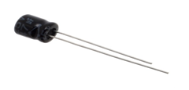](https://www.elprocus.com/wp-content/uploads/2013/11/An-electrolyte-capacitor.png)An electrolyte capacitor by [Wiki](http://upload.wikimedia.org/wikipedia/commons/d/db/47uf_Electrolytic_Capacitor.jpg)

**4. Decide the PIV (peak inverse voltage) of the diodes to be used.**

Since the peak voltage across the transformer secondary is 17V, the total PIV of the diode bridge is about (4\*17) i.e. 68V. So we have to settle down for diodes with PIV rating of 100V each. Remember PIV is the maximum voltage which can be applied to the diode in its reverse biased condition, without causing breakdown.

[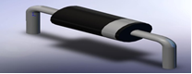](https://www.elprocus.com/wp-content/uploads/2013/11/PN-Junction-diode.png)PN Junction diode by [Nojavanha](http://www.nojavanha.com/media/2013/01/%D8%B1%D9%88%D8%A8%D8%A7%D8%AA%DB%8C%DA%A91.jpg" \t "_blank)

## Step2. Circuit Drawing and Simulation

Now that you have the idea of the values for each component and the whole circuit diagram, let us get into drawing the circuit using circuit building software and simulate it.

Here our choice of the software is Multisim.

[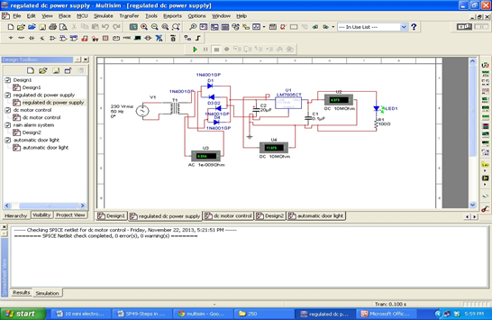](https://www.elprocus.com/wp-content/uploads/2013/11/Multisim-window.png)Multisim window

Below are the given steps to draw a circuit using Multisim and simulate it.

1. On your windows panel, click on the following link: Start >>> Programs –> National –> Instruments –> Circuit design suite 11.0 –> multisim 11.0.
2. A multisim software window appears with a menubar and blank space resembling a breadboard, to draw the circuit.
3. On the menu bar, select place –> components
4. A window appears with the title-‘select the components’
5. Under the heading ‘Database’ – select ‘Master Database’ from the drop down menu.
6. Under the heading ‘group’- select the required group. If you want to go for voltage or current source or ground. If you want to go for any basic component like a resistor, a capacitor etc. Here first we have to place the input AC supply source, hence select Source –>Power Sources –> AC\_power. After the component is placed (by clicking the ‘ok’ button), set the value of RMS voltage to 230 V and frequency to 50Hz.
7. Now again under the components window, select basic, then transformer, then select TS\_ideal. Since for an ideal transformer, the inductance of both coils is same, to achieve our output we have the change the secondary coil inductance. Now we know ratio of inductance of the transformer coils is equal to square of the ratio of turns. Since turns ratio required in this case is 19, therefore we have to set the secondary coil inductance to 0.27mH. (Primary coil inductance is at 100mH).
8. Under the components window, select basic, then diodes, and then select the diode IN4003. Select 4 such diodes and place them in a bridge rectifier arrangement.
9. Under the components windows, select basic, then Cap \_Electrolytic and select the value of capacitor to be 20microFarad.
10. Under the components window, select power, then Voltage\_ Regulator and then select ‘LM7805’ from the drop down menu.
11. Under the components window, select diodes, then select LED and from the drop down menu, select LED\_green.
12. Using the same procedure, select a resistor with the value of 100 Ohms.
13. Now that we have all the components and have an idea about the circuit diagram, let us get into drawing the circuit diagram on the multisim platform.
14. To draw the circuit, we have to make proper connections between the components using wires. To select wires, go to Place, then wire. Remember to connect the components only when a junction point appears. In multisim, the connecting wires are indicated by red color.
15. To get an indication of the voltage across the output, follow the given steps. Go to Place, then ‘Components’, then ‘indicator’, then ‘Voltmeter’, then select the first component.
16. Now your circuit is ready to be simulated.
17. Now click on ‘Simulate’ then select ‘Run’.
18. Now you can see the LED at the output blinks, which is indicated by the arrows going green in color.
19. You can verify whether you are getting correct value of voltage across each component by placing a Voltmeter in parallel.

[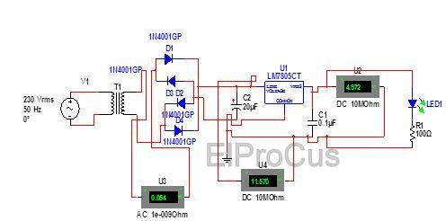](https://www.elprocus.com/wp-content/uploads/2013/11/A-complete-Simulated-Circuit-Diagram.jpg)A complete Simulated Circuit Diagram by [ElProCus](https://www.elprocus.com/" \t "_blank)

Now you have an idea about designing a regulated power supply for loads which require a constant DC voltage, but what about loads which require variable DC voltage. I leave you with this task.Furthermore, any queries regarding this concept or electrical and [electronics projects](http://www.efxkits.com/)

[Link1](https://www.elprocus.com/steps-to-building-a-project-on-breadboard-circuit/)

<http://www.instructables.com/id/How-to-make-a-Clap-Clap-on-Clap-Clap-Off-switch-/>

<http://www.instructables.com/id/Color-Changing-Night-Light/>

<https://www.electronicshub.org/water-level-controller-using-8051-microcontroller/>

<http://www.instructables.com/id/Ten-Breadboard-Projects-For-Beginners/>

<https://www.electronicshub.org/adjustable-timer/>

<https://www.electronicshub.org/electronics-projects-ideas/>

<https://www.electronicshub.org/electronics-mini-project-circuits/>

<http://www.circuitstoday.com/simple-electronics-projects-and-circuits>

<https://circuitdigest.com/electronic-circuits>

<https://electronicsforu.com/category/electronics-projects/hardware-diy>

<http://www.instructables.com/id/Lets-Make-5-More-BreadBoard-Projects-for-Begginers/>

<https://www.treehugger.com/gadgets/17-best-diy-projects-2013.html>

<https://www.electronicshub.org/electronics-projects-kids/>

<https://www.elprocus.com/simple-electronic-projects-for-beginners-in-electronics-engineering/>

<http://www.ni.com/gate/gb/GB_EVALMULTISIM/US>

( [Khairul.Basar@LntTechservices.com](mailto:Khairul.Basar@LntTechservices.com), Ps120182)

# Book & Reference:

<http://rads.stackoverflow.com/amzn/click/0521370957>

<https://www.ibiblio.org/kuphaldt/electricCircuits/>

<https://www.allaboutcircuits.com/>

Books such as Electronics for Dummies

<https://www.electronicshub.org/electronics-books-beginners/>

<https://www.wiley.com/en-us/Electronics+All+in+One+For+Dummies-p-9780470147047>

<https://news.ycombinator.com/item?id=16775744>

<http://nptel.ac.in/courses/IIT-MADRAS/Basic_Electronics_Lab/LECTURE1.pdf>

<http://nptel.ac.in/courses/IIT-MADRAS/Basic_Electronics_Lab/LECTURE1.pdf>

<http://engineering.nyu.edu/gk12/amps-cbri/pdf/Basic%20Electronics.pdf>

<https://www.electronics-tutorials.ws/pdf/basic-electronics-tutorials.pdf>

<http://webwork.utleon.edu.mx/Paginas/Documentos/Robotica/electronica/(ebook)%20Gibilisco,%20Stan%20-%20Teach%20Yourself%20Electricity%20and%20Electronics.pdf>

<http://phy415.ahepl.org/Elecronics-Kybett.pdf>

<https://www.tutorialspoint.com/basic_electronics/basic_electronics_tutorial.pdf>

<http://www-mdp.eng.cam.ac.uk/web/library/enginfo/electrical/hong1.pdf>

<http://fmipa.umri.ac.id/wp-content/uploads/2016/03/Tooley_Electronic_Circuits_-_Fundamentals_and_ApBookZZ.org_.pdf>

<https://www.circuitlab.com/textbook/?from=editor_onload_promo>

# Design Software

<https://easyeda.com/>

<http://everycircuit.com/app/>

<http://www.ni.com/multisim/>

<https://www.tinkercad.com/>

<https://www.labcenter.com/>

<http://ngspice.sourceforge.net/>

<https://www.circuitlogix.com/student_version.php>

<https://www.systemvision.com/>

<https://www.circuitlab.com/editor/#>

<https://www.partsim.com/>

<http://www.analog.com/en/design-center/design-tools-and-calculators.html?domain=www.linear.com#LTspice>

<https://www.autodesk.com/products/eagle/overview>